# Project Report

## Group: C

Team member (id and name): x23756575 Sam O Reilly

Team member (id and name): x23143509 Temuulen Munkhtaivan

Team member (id and name): x22191178 Blesson Robert

## Links:

Github: https://github.com/Saboteur0201/WebDesignGroupProject

Deployed: ________

## Requirements:

Coding Languages used:

-JavaScript

-Bootsrap

-HTML

-CSS

* Every team member designed and developed a webpage using HTML, CSS and include JS to manipulate the DOM
* The website is responsive
* The Homepage is included 8 images
* A sign up form with at least 5 fields and uses JS for validation of the fields
* Navigation across all webpages is implemented
* There is a mini game using JS that includes randomisation
* The link is provided to the deployed website
* A link to each team members' GitHub account where their work can be seen (at least 4 commits) in a public repository

<https://github.com/x23756575> (Sam O Reilly)

<https://github.com/TekuQT> (Temuulen Munkhtaivan)

<https://github.com/Saboteur0201> (Blesson Robert)

## Screen shots of Wireframes:

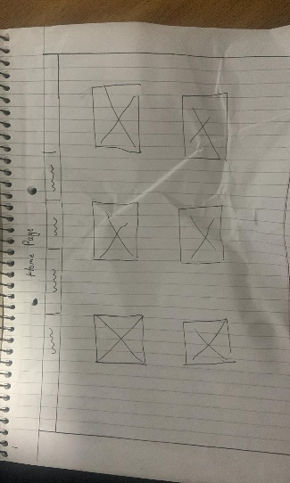 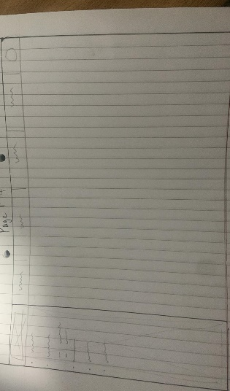

## Screen shots of Mood board:

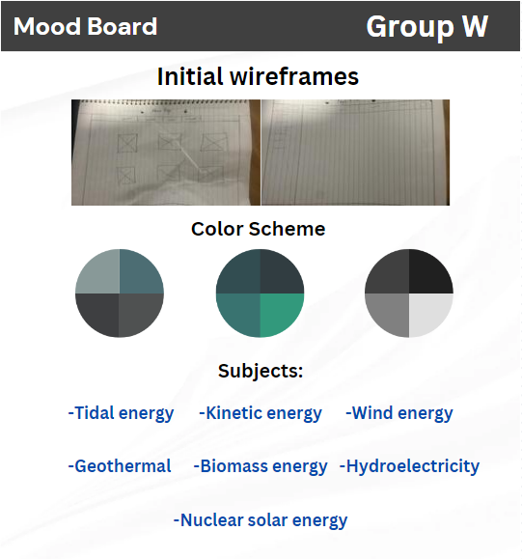

## How the website meets web standards:

Our website is user friendly, accessible, and versatile.

Our website includes HTML, CSS, Javascript.

## Coding challenge by team member 1 (Sam O Reilly):

Coded the foundation of homepage and coded the 8 pages.

Used bootstrap for homepage and all of the other pages, researched information on renewable energy and how there sustainable, searched facts and gained knowledge on those topics. Used responsive web design , so it suitable for all devices. Used javascript to add animations to some text. Made commits to the github of the changes I made.

## Coding challenge by team member 2 (Temuulen Munkhtaivan):

Coded the Mini game implementing randomization.

Created the sign up form.

Coded the hover animations and the brief info when you hover over the images.

Made commits to the github of the changes I made.

## Coding challenge by team member 3 (Blesson Robert):

Created home page (index)

Designed home page

Used bootstrap for the webpage

## List of tasks assigned to team members:

Sam O Reilly:

-The foundation of the homepage

-pages for all of the subjects

Temuulen Munkhtaivan:

-Mini Game

-Sign up form

Blesson Robert: